Executive Summary for Bakery-Plus
Wade Eckert
Bellevue University
CSD 200: Foundations of Software Development
Professor Chandra Bobba
August 10, 2025

Executive Summary
Prospect: Bakery-Plus
Sender: Academic Software Development Group
Project: Proposal to Design and Develop the Bakery-Plus Website with Online Ordering Functionality

Bakery-Plus has built its reputation on quality, freshness, and local charm. Now, with growing demand for convenience and reach, Bakery-Plus is poised to expand beyond its storefront to create a seamless, user-friendly online ordering experience. The goal is not just to replicate in-store services online, but to elevate the brand by offering customers flexibility, personalization, and rewards that foster loyalty.
Our team at Academic Software Development Group proposes to design and develop a modern, responsive website that allows customers to browse daily bakery offerings, place orders for pickup or delivery, and choose from a variety of shipping options, including same-day and next-day service. The platform will be intuitive, visually appealing, and optimized for both desktop and mobile devices.
Proposed Features:
- Daily Featured Items: Dynamically updated product listings tied to day-of-week offerings.
- Advanced Search and Filtering: Quick item discovery with category, ingredient, and dietary filters.
- Shopping Cart and Checkout: Real-time order total calculation, with pickup and shipping options.
- Account Registration: Ability to store personal, payment, and delivery information for repeat customers.
- Rewards Program Integration: Incentives for recurring customers to increase retention.
- Email Registration Option: Non-account customers can still receive promotions and coupons.
- Secure Payment Gateway: Multiple payment methods, including credit cards and pay-on-pickup.
According to a 2024 Statista report, 72% of U.S. consumers purchased food or beverages online in the past year, and small businesses offering online ordering report up to a 30% increase in monthly revenue within the first year of implementation. For Bakery-Plus, based on a conservative projection of 50 additional online orders per month at an average of $25 each, this could mean an extra $15,000 annually — not including additional customer lifetime value from the rewards program.
Our design approach will follow WCAG 2.1 accessibility standards, ensuring that all customers, regardless of ability, can use the site with ease. With our experience in UI/UX design, secure payment integrations, and scalable e-commerce platforms, we will deliver a solution that is both functional and future-ready.
We look forward to collaborating with Bakery-Plus to bring this project to life, delivering a platform that blends the warmth of your bakery with the convenience of modern e-commerce. Together, we can make Bakery-Plus the go-to destination for both local and online customers.

Appendix A – Analysis

Goals of the Website
- Enable customers to order bakery items online for pickup or delivery.
- Provide customers with a personalized, account-based shopping experience with rewards and promotions.
- Increase Bakery-Plus’s revenue and customer retention through e-commerce features and marketing integration.

Core Users
- Local Pickup Customers – Residents who want to place orders in advance for in-store pickup.
- Delivery Customers – Customers who want same-day or next-day delivery of bakery goods.
- Promotions-Only Subscribers – Visitors who register only with an email address for coupons and updates.

Personas
1. Maria Lopez: Local Pickup Customer
- Age: 42
- Occupation: Teacher
- Tech Comfort: Average
- Goals: Order quickly before work, pick up after school.
- Pain Points: Long store lines, limited time for browsing.
2. James Carter: Delivery Customer
- Age: 29
- Occupation: Freelance Graphic Designer
- Tech Comfort: High
- Goals: Order specialty pastries for clients/events.
- Pain Points: Delivery delays, unclear shipping costs.
3. Evelyn Brooks: Promotions-Only Subscriber
- Age: 65
- Occupation: Retired
- Tech Comfort: Low
- Goals: Find deals and try new seasonal products.
- Pain Points: Overly complex websites, small text, poor contrast.

User Stories
Maria Lopez – Local Pickup Customer
- As a pickup customer, I need to schedule an order for a specific pickup time, so that I can plan my visit efficiently.
- As a pickup customer, I need to pre-pay online, so that I can avoid waiting in line at the store.
- As a pickup customer, I need to see daily featured items, so that I can choose from fresh offerings.
James Carter – Delivery Customer
- As a delivery customer, I need to calculate shipping costs by entering my zip code, so that I know my total before checkout.
- As a delivery customer, I need same-day and next-day delivery options, so that I can receive items quickly.
- As a delivery customer, I need package tracking information, so that I can monitor my order status.
Evelyn Brooks – Promotions-Only Subscriber
- As a promotions-only subscriber, I need to register my email without creating a full account, so that I can receive deals without storing personal data.
- As a promotions-only subscriber, I need a simple interface with large buttons and text, so that I can navigate easily.
- As a promotions-only subscriber, I need accessible color contrast, so that I can read content comfortably.

Task Breakdown for Two User Stories
Selected Stories:
- Story 4 (Delivery Customer – Zip Code Shipping Calculation)
- Story 1 (Pickup Customer – Schedule Pickup Time)
Story | Task | Hours | Cost (@ $40/hr)
Shipping Cost Calculation | Build zip code input field in checkout | 3 | $120
Shipping Cost Calculation | Integrate shipping API for cost retrieval | 5 | $200
Shipping Cost Calculation | Create display for cost options (same/next day) | 4 | $160
Shipping Cost Calculation | Test calculation with multiple zip codes | 3 | $120
Shipping Cost Calculation | Optimize API calls for speed | 4 | $160
Story Total |  | 19 | $760
Pickup Scheduling | Create pickup date/time selection interface | 4 | $160
Pickup Scheduling | Integrate selection into order submission logic | 5 | $200
Pickup Scheduling | Validate against store hours and availability | 3 | $120
Pickup Scheduling | Add confirmation messaging | 3 | $120
Pickup Scheduling | Test with various device sizes | 4 | $160
Story Total |  | 19 | $760
Salary Research Link:
Average hourly rate calculated from Glassdoor and Indeed salary data for web developers in Nebraska:
https://www.indeed.com/career/web-developer/salaries/NE

Appendix B – Design

Accessibility & Standards
The design will comply with:
- WCAG 2.1 AA accessibility guidelines
- Section 508 (for inclusive design standards)
- Responsive Design for multiple devices
- Keyboard navigation support for users with mobility impairments
- ARIA labels for screen readers
- High contrast modes for visually impaired users
- Alt text for all non-decorative images

Order Page Wireframe
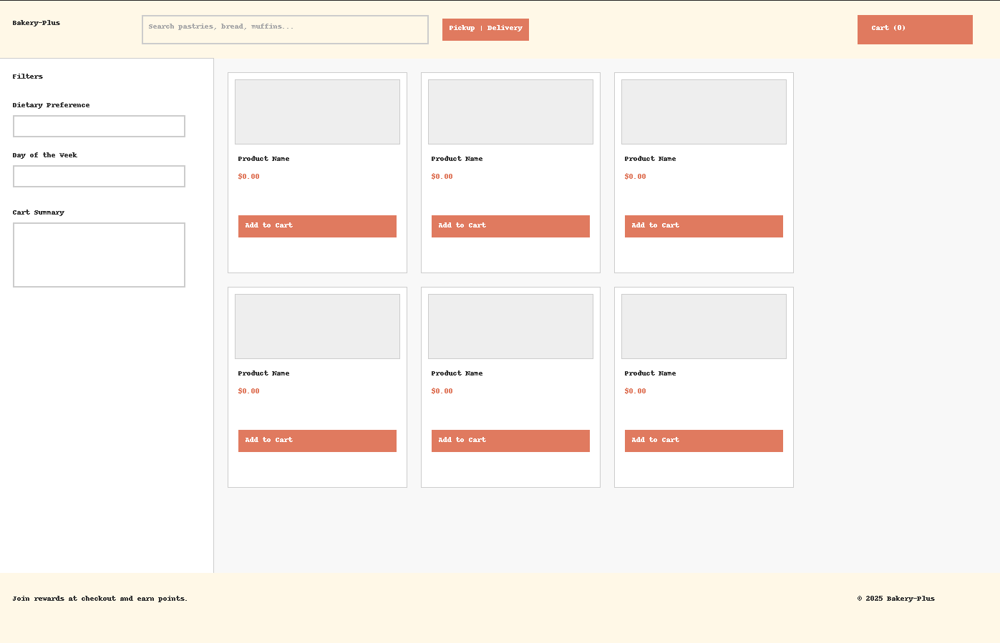

Appendix C – Assumptions
- Bakery-Plus has existing product inventory data that can be imported into the site.
- Store hours and delivery windows are fixed and will not require dynamic scheduling logic at launch.
- Payment processing will be handled via an existing, PCI-compliant third-party service.
- Bakery-Plus will provide branding assets (logo, color scheme, images).
- Rewards program rules and logic are already defined before development starts.

